Winter Revue: Once More, With Feeling! 5th Dec 2010

CREW:
TD: Dave Reading
LD: Hannah Morton
LX Prog: Rob Paines
SD: Rob Jones
SM: James Calder

LX Team: Clayton Peters, Chris Duncan, Hannah Evans, Richard Owen, Tom Marshall, Theresa Crisham

SX Team: James Mozden, Nichola Louis, Rachel B, Kal

Stage: Mustafa Pathan, Katie Allen, Matt Leach

N.B. Mike Frost & Rob Paines will be in and out due to Medics Revue.

EQUIPMENT:

LX:
- 14x Chromadomes with 2x 12 way controllers. Radial cabling.
- 10x Colourblocks with 2x 15 way controllers. Daisy chaining.
- 6x 6 Parcan Bars
- 4x Mac 250
- 4x Mac 300
- 4x Sunstrips
- 3x Source Four Zoom
- 2x Blinders/Moles
- 2x X-Bases
- 2x Truss towers
- 1x Followspot + Dimmer
- 1x Hazer
- 1x Atomic 3000
- 1x Chamsys MQ100 OR MQ200
- 1x Chamsys Execute Wing
- 1x Chamsys Playback Wing
- As many LED Parcans for understage illumination and House illumination
- Dimmer Racks
- DMX runs

SX:
- Midas + PSU
- D&B + Amps
- Drive Racks and Outboards
- Mons Amps
- Turbo Wedges
- 6 Radio Mics + Receivers
- 10 Radio Mic Capsules
- 3 Sennheiser Handhelds + Receivers
- All Mics at disposal

Stage:
- Full deck
- Some sort of draping for rear wall with masking for rear entrance
- 2 entrances, DSR, USC
- "Copa" stairs for front of stage
- 1x treads from Stags Head for DSR
- 1x treads from PAU House for USC

Props:
- 12x electric candles
- 3x 1ft podiums
- 2x gym benches
- 1x chair
- 1x table?

BAND:
- Keys 1
- Keys 2
- Guitar
- Bass
- Acoustic Drum Kit
- Flute & Alto
- Clarinet & Tenor
- Trumpet
- Trombone

RUNNING ORDER:
- Out Tonight Rent
- What Is This Feeling? Wicked
- Lay All Your Love On Me Mamma Mia
- I’m Alive Next to Normal
- The Morning Of The Dragon Miss Saigon
- You Don’t Know This Man Parade
- The Nicest Kids In Town Hairspray
- Somebody To Love We Will Rock You
- It’s My Life / Confessions Part II Glee
- He Lives In You The Lion King
- I’ll Never Be Jealous Again The Pajama Game
- Elephant Love Medley Moulin Rouge

INTERVAL

- Electricity Billy Elliot
- Betrayed The Producers
- How I Got The Calling Sister Act
- That Guy Blood Brothers
- Cell Block Tango Chicago
- Schadenfreude Avenue Q
- Sit Down You’re Rocking The Boat Guys and Dolls
- Business Time Flight of the Conchords
- American Idiot American Idiot
- I’m All Alone Monty Python’s Spamalot
- Still Hurting The Last 5 Years
- What A Feeling Flashdance

N.B. Compere will be in and out throughout the show. As of yet, don't know when.

TRACK REQUIREMENTS:
- Out Tonight
Upbeat track! Loud, lairy and fun! Ensemble piece with one soloist.
LX: Bright, colourful, flashy, hazey. No FS
SX: One soloist

- What Is This Feeling?
A humorous track but is fairly serious. Two soloists with ensemble joining in later.
LX: Bright but gentle lighting, not too flashy, low level of haze, no strobe
SX: Two soloists

- Lay All Your Love On Me
As above.
LX: Slight disco feel so be more flashy!

- I’m Alive
One soloist. No ensemble. Soloist will sing at Compere and then will jump around on stage before heading in to the audience and using the front row. At end of track, soloist will sit on "Copa" stairs.
LX: No instructions...Do you what you feel! Will require "Copa" stairs to be lit. Illuminate front row. FS required.
SX: One soloist

- The Morning Of The Dragon
Ensemble piece. No soloists.
LX: Minimal lighting, dark atmosphere!
(STRAIGHT INTO 6)

- You Don’t Know This Man
One soloist. No chorus.
LX: FS required. Gentle, emotional, mood lighting
SX: One soloist

- The Nicest Kids In Town ]
One soloist. Ensemble piece.
LX: Flashy, colourful, hazey!
SX: One soloist

- Somebody To Love
One soloist. Female ensemble.
LX: FS soloist, ensemble minimal lighting, can be flashy though.
SX: One soloist
Stage: 2 gym benches required

- It’s My Life / Confessions Part II
Two soloists. Female ensemble.
LX: Gleek it up!
SX: Two soloists.

- He Lives In You
One soloist. Ensemble piece.
LX: Start on B/O. Six cast enter SR with electric candles. Bring up lights at first chorus "He lives in you..." Where fade up should finish by "you". Be very colourful
SX: One soloist
Stage: Electric candles

- I’ll Never Be Jealous Again
Two soloists. No ensemble.
LX: Gentle lighting. Moody atmosphere.
SX: Two soloists
(STRAIGHT INTO 12)

- Elephant Love Medley
Six couples. No movements once in position.
LX: Romantic feel.
SX: Flood micing
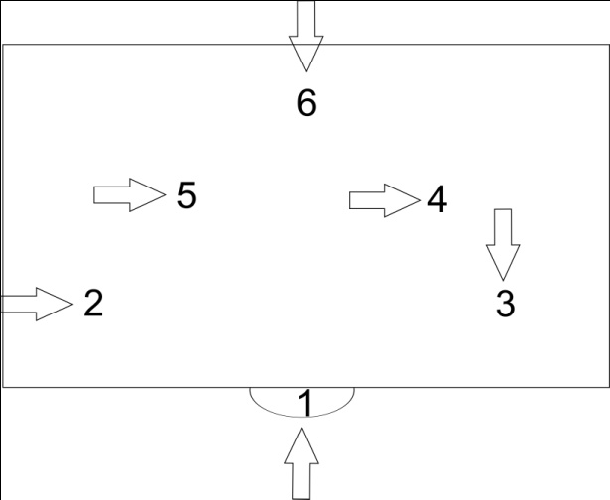

INTERVAL

- Electricity
One soloist. Ensemble piece.
LX: FS soloist. High energy, happy
SX: One soloist

- Betrayed
One soloist. No ensemble
LX: FS soloist on chair? Jail gobo? Dark at first and then when soloist gets up, bring up lights. Match parts of song to colour themes: Dark to bright to dark etc.
SX: One soloist
Stage: One chair
- How I Got The Calling
Four soloists. Ensemble piece.
LX: Funny and humorous. Little flashy!
SX: Four soloists

Compere here! Bad joke which leads to "bet the Crew liked it though!" cue B/O. When compere apologises, LX up.

- That Guy
Two soloists. No ensemble. No dancing.
LX: No individual spotting.
SX: Two soloists

Compere here! Quick pack change!!!

- Cell Block Tango
Six soloists. Six girls + one guy!
LX: West End Styley! Flashy, dark romance.
SX: Six soloists.

Compere here! Stage: Quick pack change!!!

- Schadenfreude
Two soloists. One on stairs, other behind on stage.
LX: Comical and funny. Spot both soloists.
SX: Two soloists.

- Sit Down You’re Rocking The Boat
One soloist. Ensemble piece.
LX: Whatever you feel!
SX: One soloist

- Business Time
One soloist. Three dancers at end. No other ensemble. Narrator is on stage.
LX: Sexy, moody. OTT!
SX: One soloist.
Stage: One chair. Maybe a table too.

- American Idiot
Three soloists. Ensemble piece.
LX: Watch video from Tony Awards. As close to that including strobe! Strobe special programming!
SX: Three soloists
Stage: Three podiums required. Even spaced across front of stage.

- I’m All Alone
Two soloists. Ensemble at end.
LX: Comical feel, easy going!

- Still Hurting
One soloist. No ensemble.
LX: Quiet and tame. Saddest song of revue!
SX: One soloist.

- What A Feeling
One soloist. Full ensemble
LX: GO NUTS!
SX: One soloist!

